HDFS Name Node Real Time Analytics

Screenshots

**Landing Page:**

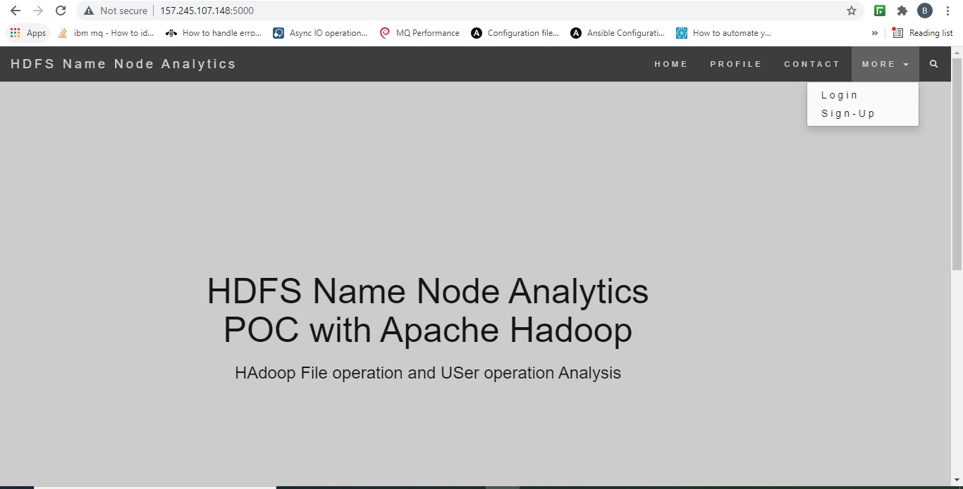

**Dashboard**

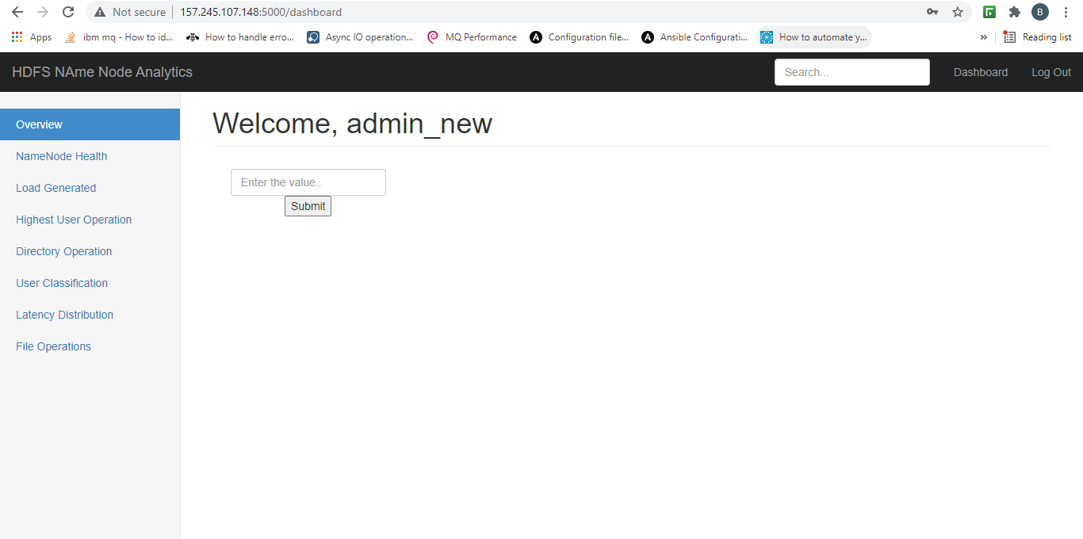

**Name Node Health:**

Name Node Health and Status

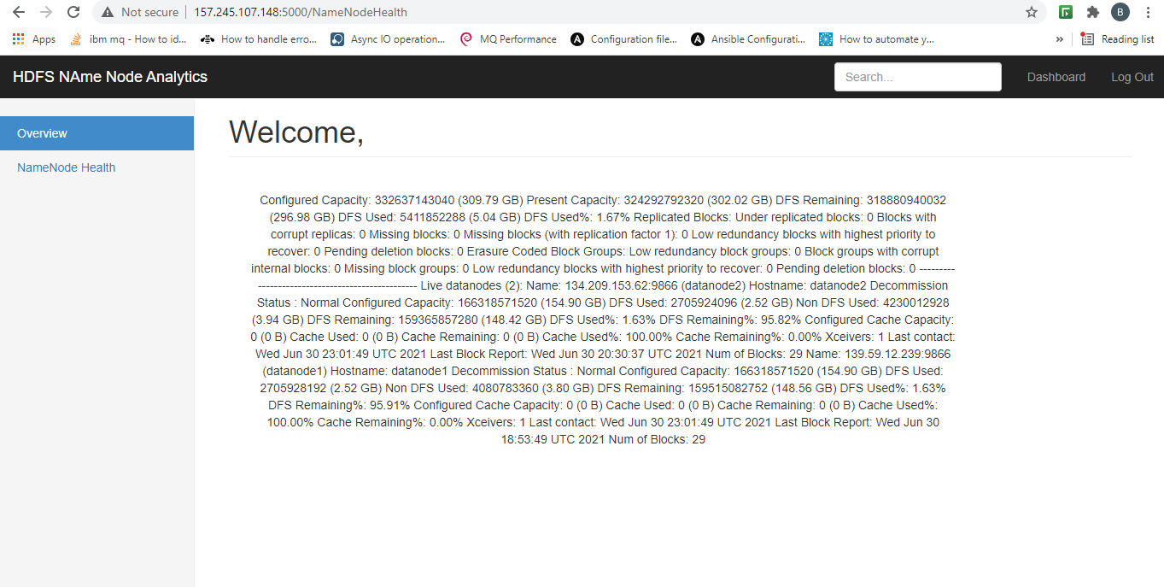

**Load Generated:**

What generated load in last 3 hours

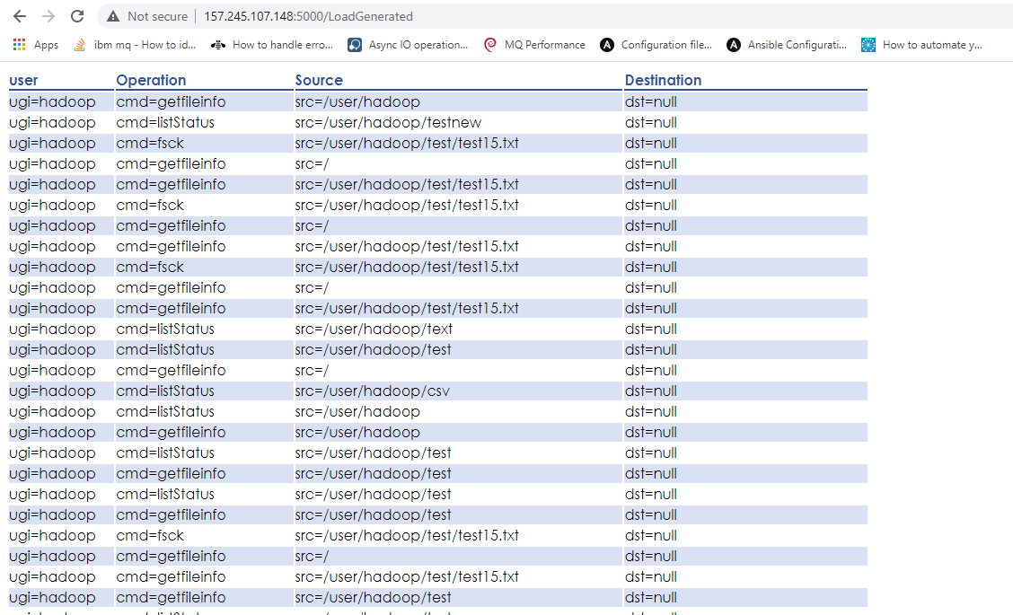

**High User Operation:**

Which user had the greatest number of operations

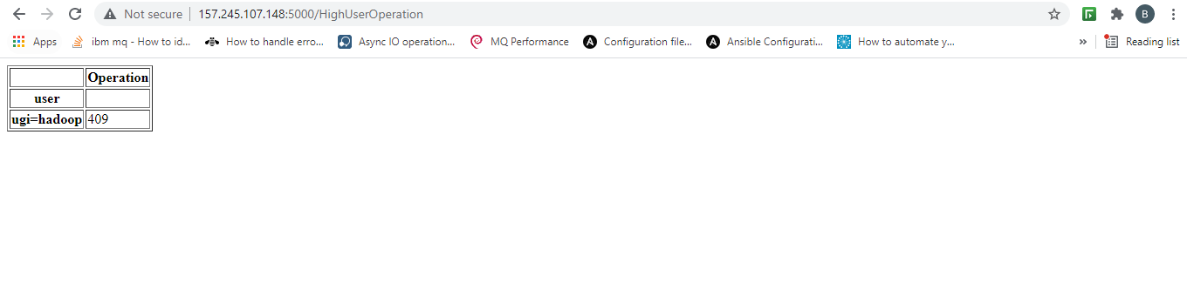

**Directory Operation:**

In the last 3 hours which directory had highest number of operations

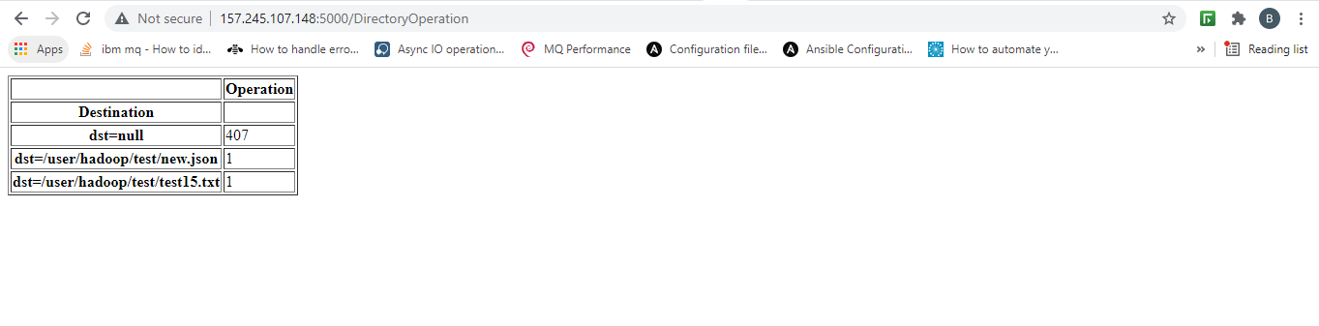

**User Classification:**

In the last 3 hours classify the total number of operations

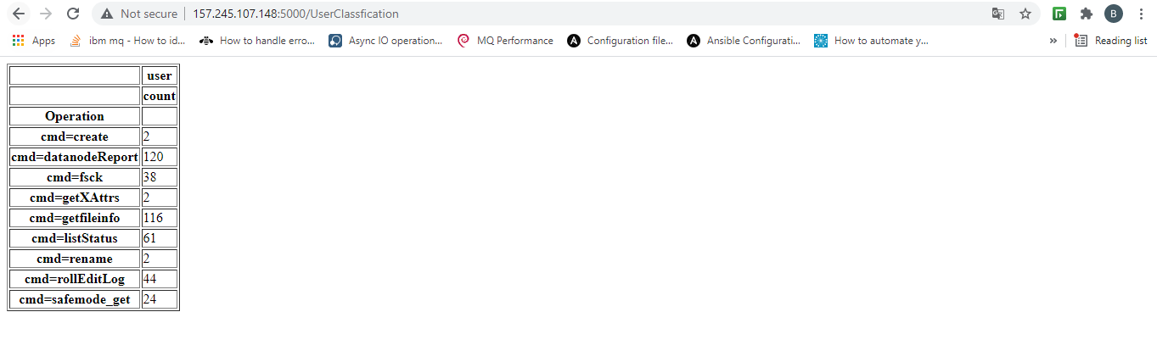

**Time and Latency Details:**

Which operation took more time and 90th and 95th percentile of each operation

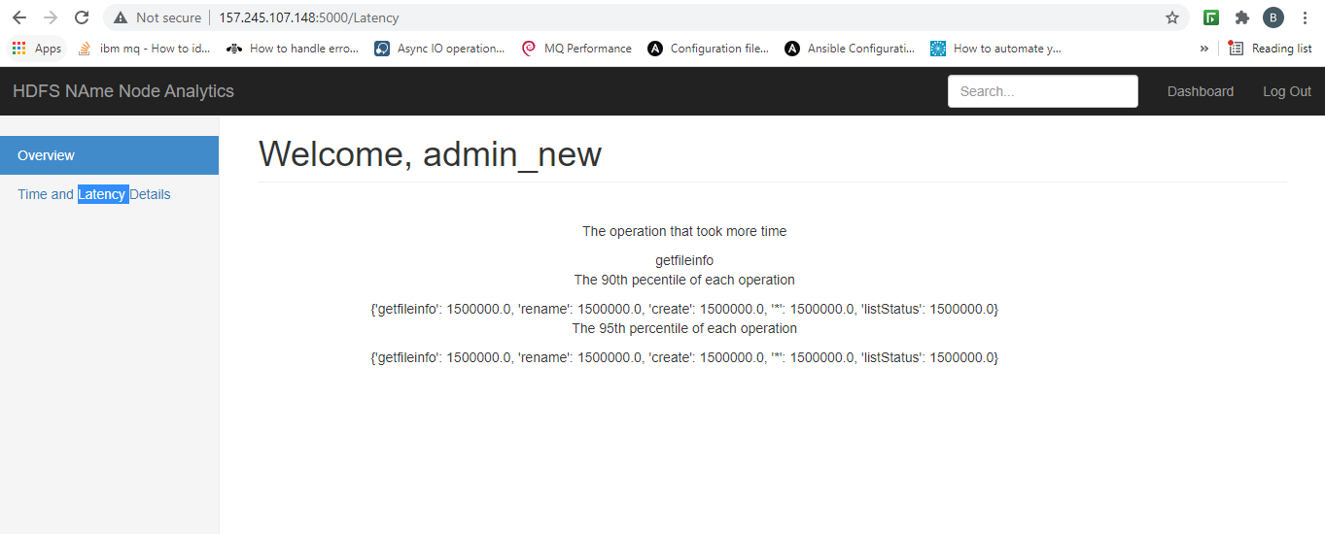

**File Operations:**

Which file got generated in last 1 hour and details of those files like, Blocks, Racks, Data nodes ,Location. And also newest and oldest file in a particular directory

